For this task nine sets of histograms were created from three tracks, each producing histograms for their chromagrams, spectrograms and MFCCs. MFCCs are too complex to intuitively analyse, and the spectrogram has more than 1000 features, therefore I’ll compare the contents of the chromagrams. Below are histograms for the chromagrams of three different songs of different genres. The chromagrams show the energy levels over each note (C#, D, D# etc.).

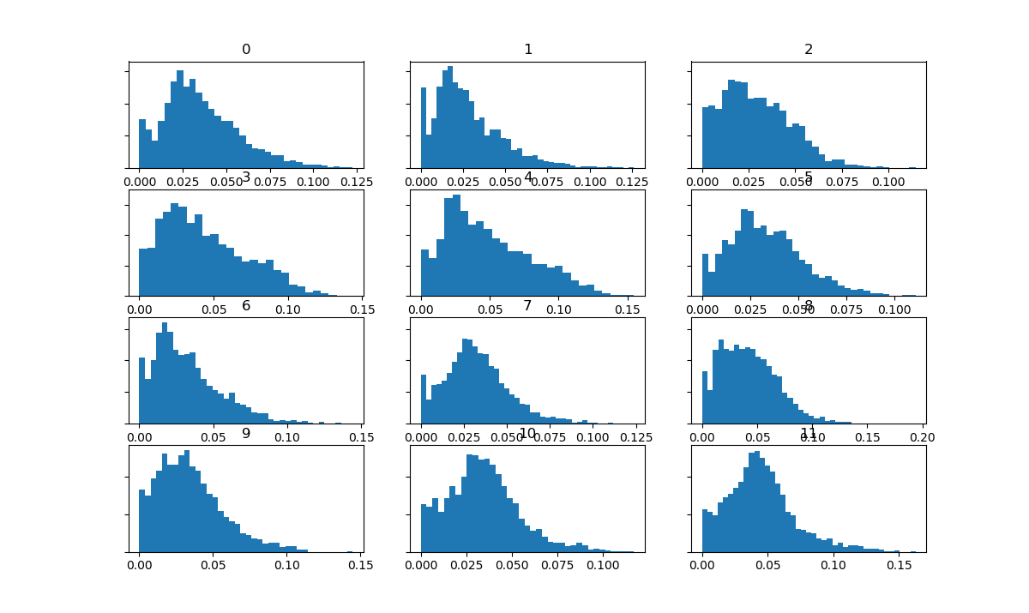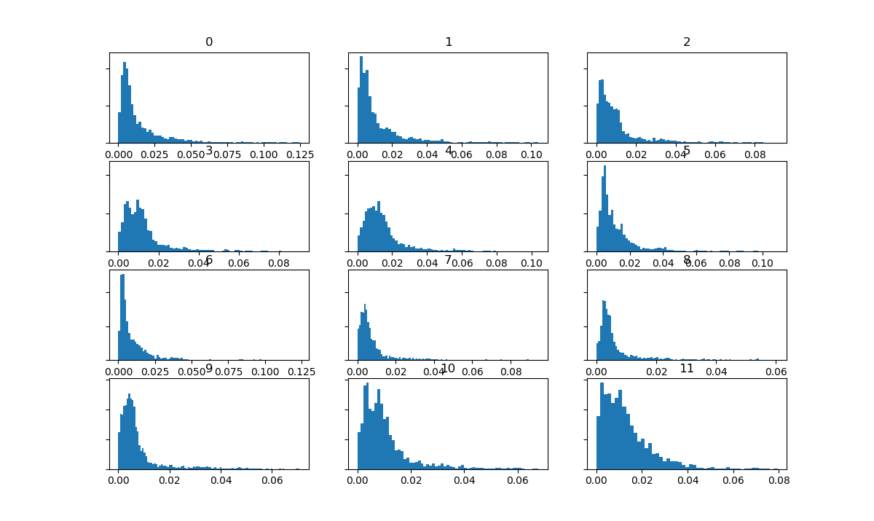Rock Song Hip Hop Song

Electronic Song

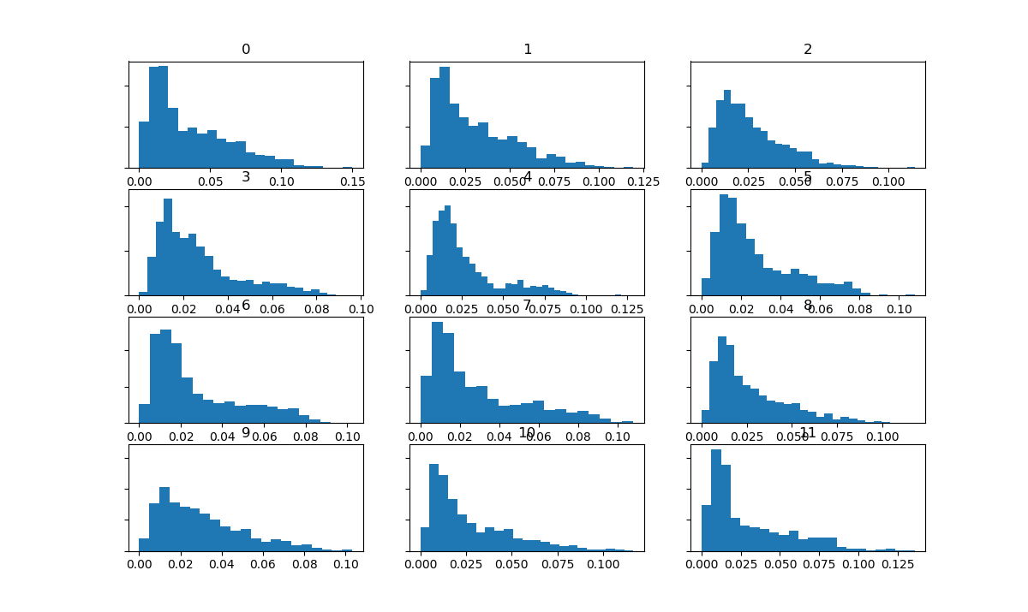

Looking at these histograms as a whole, significant differences between the tracks are visible. It appears that the rock song contains higher energy levels on average as shown by the data present at higher energy levels on various notes, while the other two tracks have much more noticeable peaks in energy at lower levels which drastically dips off at higher energy levels. This correlates with the sound of the rock song, which is loud and high-energy. The histograms overall show that the hip-hop track contains the lowest energy levels of the three tracks – which becomes apparent when listening to the track as it sounds much more “mellow” than the other two tracks. Its energy level spikes at the lower end of the histogram – although the B note (histogram 12) does show more energy overall – perhaps indicating high prevalence of this note throughout the track. The histogram for the electronic track also shows dips in data after the low-level energy, however it does maintain some data over higher energy levels. The A note in particular appears to contain somewhat similar amounts of data over the various levels of energy.